**Elizabeth Duff Award Winner 2019 – Ren Forteath**

‘Labours of Love’ is a brand new musical celebrating the midwife-woman relationship and also the work of SANDS. Produced by Fledgling Musical Theatre Company and set in a fictional maternity unit, it follows the stories of five women with very different backgrounds as they become mothers, and also the staff who work there.

The musical features songs from several genres including pop, gospel and ballad. There are comic songs and love songs, joyous celebrations of new life and moving laments as two of the characters have difficult experiences.

‘Chrissie’ lost her first baby, Rebecca, two years ago and is pregnant again. She had grief counselling from SANDS and meets regularly with a befriender, but is anxious about bonding with this new baby after her previous experience. In Act 2 we see her in labour, being cared for by the same midwife, Alice, who delivered Rebecca, and we meet baby Megan.

‘Judy’ is a teenager who did not plan to be pregnant, or for her boyfriend to leave her, but with the support of her parents she is facing the future with hope. However, in Act 2, tragedy strikes when she goes into labour prematurely and is rushed to hospital. The baby is born but there are further complications as Judy begins to haemorrhage and the doctors have to work quickly both to save her and to resuscitate the baby, described in the frenetic song “When the Buzzer Goes”. By the song’s end the bleeding has been stopped but tragically, the baby has not survived. There follows a heartbreaking scene as Judy begins to come to terms with her loss.

The other Mums to be are Annie and Frieda, both first timers who have very different experiences of labour, and Rachel, an old hand who has a serene water birth with the support of her Mum, Michaela, during the title song ‘Labours of Love’.

The other central storylines feature the staff of the maternity unit. Student midwife Ruth is in the final year of her studies. She is deeply affected by Judy’s experience, but is supported by her mentor Alice to reflect and learn from it. Her dialogue in the final scene highlights the passion midwives feel for their work and the dedication they give to their patients. The final song is an uplifting celebration of midwifery and the with-woman relationship. Ruth is also the focus of a romance involving junior doctor Nick. There is a dash of intrigue too, between midwife, Lorna, and obstetric registrar husband, John, when he discovers she has been keeping secrets from him.

The show was largely funded by an Iolanthe foundation grant of £1500; the Elizabeth Duff Award. I was able to speak to Elizabeth in London at the award ceremony and she told me how delighted she was that a musical show has been written about the work of midwives and the passion we feel about what is, for many, a calling. The award money was spent on hiring the rehearsal space and buying set construction materials, props and costumes and headset microphones as well as hiring stage lighting. Fledgling as a company were very grateful for this money as it gave us the opportunity to realise our dream of staging out premier production.

The show was also fundraising for the work of SANDS, who allowed their name to be used in Judy and Chrissie’s stories to highlight the valuable work they do. SANDS also had a stall in the foyer to provide information on their support services for any audience members affected by the show’s content. We were very grateful to SANDS for their support, which even extended to training the cast to enhance their performances.

The company have varying degrees of experience in amateur theatre and found this to be a challenging, yet very rewarding production. We found ourselves at rehearsal sharing our own birth stories and reflecting on – and often laughing about - things which, for some of the cast, happened many years ago. This shared experience brought us closer together as a company, gave context for our characterisation and motivated us to give the audiences a very memorable experience which we hope was, in a strange sort of way, cathartic.

‘Labours of Love’ was shown at Dumfries Baptist Church Centre from Wednesday 13th to Friday 15th November 2019.

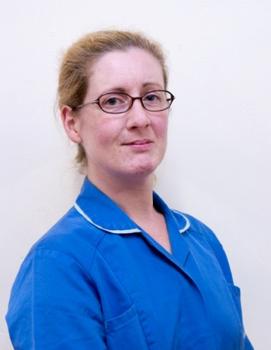 Ren Forteath as Senior Midwife Jane Robbins

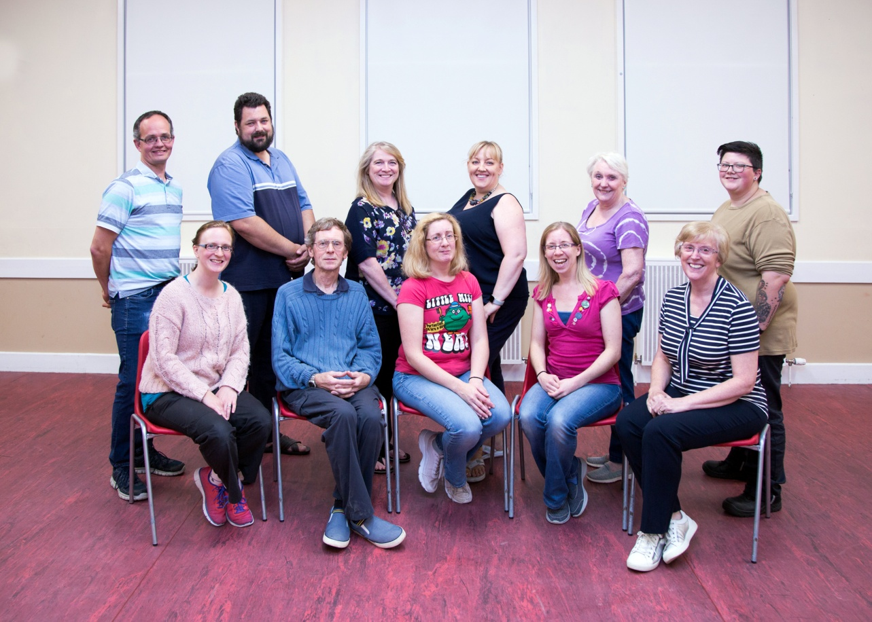

Fledgling Musical Theatre Company. From back left: Stig Rune Nordkil, Gary Forteath, Sharon F W Mitchell, Sharron Harper, Jane McFarlane, Charlie Porter, and from front left, Sharon Rossi, Ewen Flint, Ren Forteath, Holly Titcombe and Karen McMeeken.

Below, the cast in rehearsal:

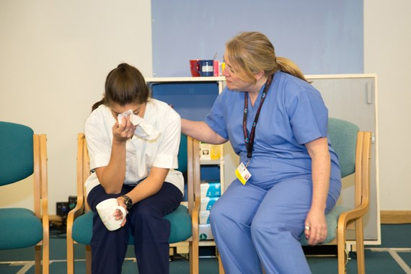 Student midwife Ruth comforted by mentor Alice after the loss of Judy’s baby.

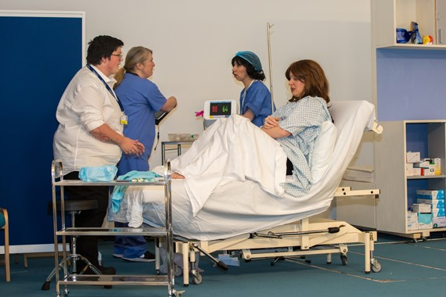Teenager Judy goes into premature labour and is treated by Dr John Smith and MW Alice Renshaw. Paeds reg Robyn Lovett gets ready for the new arrival.

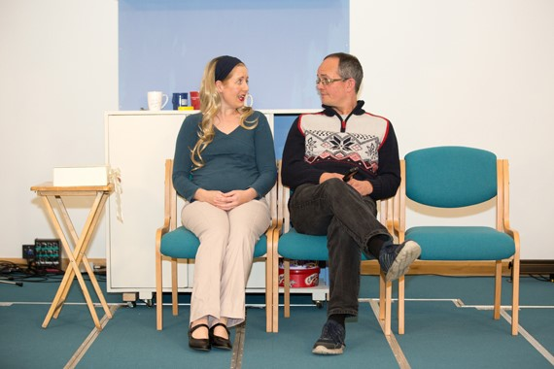Chrissie and Jim discuss their feelings.

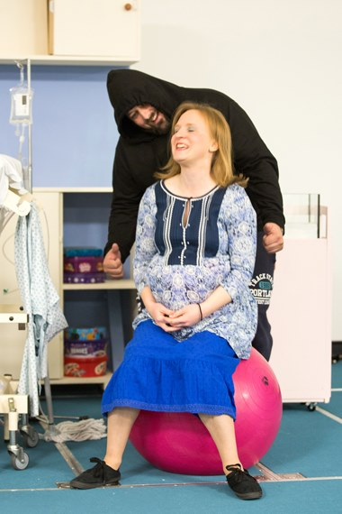 ‘I can do this!’ says Freida, while partner Barry gives encouragement!